Synergy Network DAG Validator Cluster Integration and Security Hardening Report
  - Merged and expanded report: earlier integration plan + direct review of src.zip validator/client source
March 19, 2026
Supersession note. This document merges and supersedes the earlier DAG integration plan by adding a repository-aware source review of the src.zip runtime bundle. The earlier report was specification-grounded; this version keeps the same architectural recommendation but tightens it using direct code findings.
Coverage note. The current merge set includes the earlier report, the src.zip validator/client source bundle, and the uploaded Synergy specification / whitepaper corpus. The synergy-node-control-panel source itself is still not present in the merge inputs, so control-panel changes remain design-level recommendations rather than a file-by-file control-panel audit.

Quick navigation
- Executive conclusion
- What is new in this merged report
- Full review scope and coverage
- Current implementation reality from the source tree
- Recommended target architecture
- Dependency-ordered integration roadmap
- DAG-specific security enforcement plan
- Concrete file touchpoint plan
- Remaining blind spots and most useful next inputs
- Appendices: source inventory, document corpus, DAG config, DAG RPCs, Mermaid snippets

Executive conclusion
The core recommendation does not change after source review: Synergy should not pivot to a pure network-wide DAG-finality design. The right move is still a cluster-local certified DAG that improves dissemination, availability, batching, and deterministic pre-ordering under unchanged PoSy quorum-certificate finality.
The source code makes that recommendation stronger, not weaker. The current runtime is explicitly organized around a linear finalized chain, a proposer loop fed from a flat transaction pool, and a dual-quorum QC path that remains the only hard settlement artifact. There is no existing raw DAG message plane, no DAG-aware block header commitment, and no DAG-aware sync subsystem in the current code. A safe rollout therefore means adding a DAG data plane beneath PoSy finality, not replacing PoSy’s final commit path.
The merged conclusion is blunt:
- Use a DAG inside each validator cluster, not across the whole network in the first release.
- Keep PoSy dual-quorum QC as the only canonical finality mechanism.
- Require availability certification before ordering.
- Use encrypted batches inside the DAG so the DAG does not become a new MEV leak surface.
- Export only compact checkpoints across clusters, not raw vertex gossip.
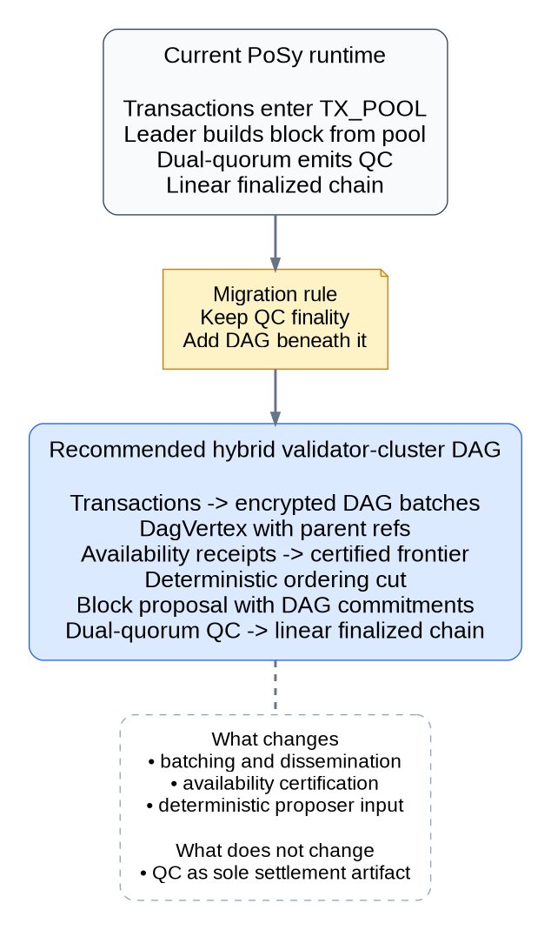
Current PoSy path versus target hybrid validator-cluster DAG
Source anchors: src/consensus/consensus_algorithm.rs, src/consensus/dual_quorum.rs, PoSy_updated.docx, 03-proof-of-synergy-consensus.md, Synergy_Network_Roadmap (1).docx.

What is new in this merged report
The earlier report already had the right architectural direction. What this merged version adds is implementation reality.
- It screens 82 files from src.zip and maps the real code touchpoints for DAG integration.
- It identifies concrete implementation gaps that were not visible from specifications alone.
- It adds an explicit source-inventory appendix so the review boundary is visible rather than implied.
- It adds more diagrams and a Mermaid-source appendix so the architecture can be reused in GitHub docs and ADRs.
The highest-value deltas from code review are these:
- consensus_algorithm.rs is the primary insertion point for a cluster DAG manager, because the current block proposal path still reads directly from TX_POOL.
- dual_quorum.rs currently synthesizes votes locally by iterating over active validators instead of receiving vote objects over the network. That means the present QC path is partly a local simulation path, not yet a full networked BFT vote-exchange layer.
- p2p/messages.rs has only block, transaction, header, body, peer, and status messages. There are no DAG message types yet.
- sync/*.rs is strictly linear chain sync. There is no DAG artifact sync for archive, audit, or DA roles.
- validator.rs contains a real configuration mismatch: registry default cluster_size = 7, but reorganize_clusters() hard-codes MAX_CLUSTER_SIZE = 5. DAG thresholds cannot be implemented cleanly until that mismatch is fixed.
- EntropyBeacon::generate_epoch_randomness() mixes the previous QC hash with the current wall-clock timestamp. If each validator derives epoch randomness independently this way, they do not automatically converge on the same randomness. DAG ordering cannot inherit that ambiguity.
- role_profiles.rs already defines Archive Validator, Audit Validator, and Data Availability roles, which is good operational scaffolding—but those roles are still mostly declarative in this bundle, not a finished DAG implementation.

Full review scope and coverage
The goal of this merged report is to reduce blind spots, so the review boundary is explicit.

Source bundle coverage summary
- Consensus — 8 files. Leader loop, QC, entropy, VRF, governance, synergy score, and cartel logic.
- P2P — 4 files. Wire messages, peer discovery, gossip behavior, bootstrap, and allowlists.
- Sync — 6 files. Header/body sync today and future DAG artifact sync requirements.
- RPC — 3 files. Operator visibility, client semantics, and status surfacing.
- Core state — 17 files. Block, transaction, validator, token, wallet, runtime, and config logic.
- Role binaries — 20 files. Validator, archive, audit, DA, gateway, relayer, observer, and specialist node entrypoints.
- Adjunct modules — 23 files. Cross-chain, execution, PQC, address, relayer, and DA-adjacent patterns screened for indirect DAG implications.
The full src.zip inventory was screened. The files with direct DAG impact were reviewed in depth; adjunct files were screened for indirect implications, rollout topology, cross-chain checkpointing patterns, encryption patterns, and role boundaries.

Uploaded document corpus coverage
The merge also uses the uploaded Synergy protocol and whitepaper corpus, including the consensus, roadmap, security, naming, configuration, wallet, node, rewards, and appendices material. Duplicate copies across separate uploads and the whitepaper zip were deduplicated conceptually during review.
The only non-content files intentionally ignored were bundle noise such as .venv, .DS_Store, and __MACOSX artifacts.

Current implementation reality from the source tree

Consensus engine: where DAG actually plugs in
src/consensus/consensus_algorithm.rs is the main runtime spine. It loads the shared chain and validator registry, derives timing and validator thresholds from config and environment, chooses a leader, validates pending transactions, builds a block proposal, executes the dual-quorum path, applies token state changes, distributes cluster rewards, updates synergy scores, and handles epoch transitions.
That makes it the correct place to add a ClusterDagEngine or equivalent. The new subsystem should sit between transaction ingress and block proposal creation. In other words, the proposer should stop building from the flat mempool and instead build from a deterministic certified frontier generated by the cluster DAG.
Two current behaviors matter immediately:
- the runtime clears the transaction pool wholesale after a successful block commit, which is too coarse for DAG batching and receipt-based retirement;
- transaction validation currently allows a best-effort path where signature verification is skipped if the sender public key is not known locally.
That second behavior may be tolerable for testnet wallet UX; it is not tolerable for DAG author messages, availability receipts, or certificates. Every DAG-control artifact must have strict author authentication.

Dual quorum and entropy: finality path stays, but needs hardening
src/consensus/dual_quorum.rs validates the block proposal, calls collect_votes(), computes validation and cooperation quorums, and emits a QuorumCertificate. The structure is useful for a hybrid DAG design because it already separates proposal validation from final commitment.
But the source also exposes a major implementation reality: collect_votes() currently loops over active validators and creates votes locally. That means the current QC path is not yet a networked exchange of validator vote objects. The hybrid DAG rollout should therefore avoid piling new security assumptions on top of this local simulation path. The safer sequence is:
- add the DAG dissemination and availability layer;
- add deterministic ordering-cut verification;
- then tighten the networked vote/certificate path if needed.
Entropy also needs canonicalization. EntropyBeacon::generate_epoch_randomness() hashes the previous QC plus a locally generated ML-KEM secret and the current timestamp. Unless there is an external protocol step ensuring identical input material across validators, that is not a safe long-term randomness primitive for shared DAG ordering or shared parent selection.

Validator clustering, synergy score, and cartel logic
src/validator.rs and src/consensus/synergy_score.rs confirm that PoSy is already cluster-centric in implementation, not only in prose. Validators are tracked with stake, reputation, performance, synergy score, and cluster membership. Rewards are then distributed cluster-first in src/token.rs using normalized synergy score.
That is an excellent fit for a cluster-local DAG, because it means the architecture already treats the cluster as a meaningful accountability and reward boundary.
The bad news is that current cluster math is inconsistent:
- the registry default sets cluster_size = 7;
- the config default also sets validator_cluster_size = 7;
- but reorganize_clusters() hard-codes MAX_CLUSTER_SIZE = 5.
You cannot safely define DAG receipt thresholds, parent-diversity policies, censorship monitors, or equivocation windows until that is canonicalized.
The cartel-detection path also needs work before it can secure a DAG rollout. CartelDetectionEngine uses a cartel_size_threshold of 10, which is already larger than the current beta cluster size. And record_vote_for_cartel_detection() is only invoked from the consensus path in a way that records a very limited slice of behavior. For DAG collusion, censorship, and parent omission, Synergy will need actual DAG evidence capture, not just a thin after-the-fact proposer success signal.

P2P and sync: ready for extension, not ready out of the box
src/p2p/messages.rs is still a small linear-chain schema:
- handshake
- block / transaction
- get blocks / blocks
- get block headers / bodies
- peers / ping / status
There are no vertex, receipt, certificate, ordering-cut, batch-fetch, checkpoint, or evidence messages.
That said, the existing P2P stack gives the DAG rollout some useful hooks. The handshake already carries a capabilities vector and an optional validator_address, and p2p/networking.rs already has strict-validator allowlisting, bootstrap-only mode, seed servers, DNS bootstrap, and peer status collection. In practical terms, DAG rollout can use capability negotiation and existing trust boundaries rather than exposing a new public attack surface.
The sync subsystem is also explicitly chain-shaped. src/sync/manager.rs, full_sync.rs, fast_sync.rs, and validation.rs are built around block heights, headers, bodies, and transaction-root verification. That is fine for the finalized chain, but it means a DAG rollout needs a parallel artifact-sync path for archive, audit, and DA roles.

Block, transaction, RPC, and role surfaces
src/block.rs confirms that block headers currently commit to block index, parent hash, validator ID, nonce, timestamp, and transactions_root. There is no field yet for:
- ordering-cut root;
- availability root;
- certified frontier root;
- batch/blob commitment root.
Those additions need to be introduced carefully because they affect block hashing, block verification, explorer/indexer assumptions, and sync validation.
src/transaction.rs is a straightforward signed transaction object. It does not yet model encrypted DAG batches or blob references, so the DAG rollout should add a batch layer rather than overloading the base transaction object itself.
src/rpc/rpc_server.rs already exposes transaction pool, validator activity, and block-validation status. That is useful because it provides a natural place to add DAG diagnostics. But it currently conflates “pending pool” semantics with a plaintext mempool. That will need to change once DAG ingress uses encrypted batches and staged acceptance states.
Finally, src/role_profiles.rs is more helpful than it first looks. The bundle already declares profiles for:
- validator
- archive_validator
- audit_validator
- data_availability
- rpc_gateway
- relayer / verifier / governance / treasury / security-council roles
That means the operational model for a DAG rollout already exists conceptually. What is missing is the implementation behind the DA and audit surfaces, not the role taxonomy.
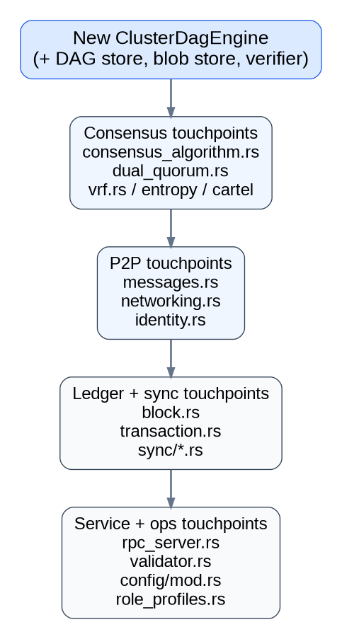
Primary code touchpoints for a new cluster DAG subsystem

Highest-impact code findings
- Local vote synthesis in collect_votes(). The QC path is not yet a full network vote exchange. Keep DAG rollout below QC finality and avoid assuming mature vote networking on day one.
- Wall-clock entropy input. EntropyBeacon mixes in current time. Replace that with externally reproducible epoch randomness before DAG ordering depends on it.
- Cluster-size mismatch. MAX_CLUSTER_SIZE = 5 in validator reorganization while config defaults say 7. Canonicalize beta cluster size before DAG certificate thresholds are defined.
- No DAG wire schema. NetworkMessage currently has no vertex, receipt, certificate, cut, or checkpoint variants. Add them explicitly and gate them with capability flags.
- Block-only sync. Archive, audit, and DA nodes cannot reconstruct DAG state from the current sync stack. Add bounded DAG artifact sync.
- Best-effort transaction authentication. Signature verification can be skipped for unknown transaction senders. DAG control artifacts must never use that relaxed path.
- Underpowered cartel thresholds. Current cartel thresholds exceed beta cluster size. Rework them and use DAG-native evidence.
- Declarative DA role, thin implementation. The topology hook exists, but the blob-store and proof machinery do not yet exist in the source bundle.
Source anchors: src/consensus/consensus_algorithm.rs, src/consensus/dual_quorum.rs, src/validator.rs, src/consensus/synergy_score.rs, src/consensus/cartel_detection.rs, src/p2p/messages.rs, src/p2p/networking.rs, src/sync/manager.rs, src/block.rs, src/transaction.rs, src/rpc/rpc_server.rs, src/role_profiles.rs.

Recommended target architecture
The target architecture should be a hybrid validator-cluster DAG with unchanged PoSy finality.
Inside each active validator cluster, transactions are grouped into bounded batches. Each batch becomes a DagVertex with parent references, author identity, round and epoch metadata, and a commitment to the batch or batch blob. Peers acknowledge availability only after they can actually fetch and retain the batch data. Once a threshold is met, the vertex becomes availability-certified. The proposer then computes a deterministic ordering cut from the certified frontier and builds a normal block candidate. Validators verify both the cut and the resulting state transition. PoSy’s dual-quorum path then emits the final QC.
Across clusters, only compact checkpoint artifacts should move. The first release should not attempt a single global raw DAG. That would inflate surface area, confuse finality semantics, and burden sync/storage before the local-cluster design has proven itself.

Recommended artifact set
The source tree does not contain these objects yet, so they should be added explicitly rather than implied.
- DagBatch – a bounded transaction set or a bounded set of ciphertext-shard references.
- DagVertex – author, epoch, round, parents, batch commitment, previous-author link, timestamp, sequence number, signature.
- AvailabilityReceipt – signer identity, vertex commitment, batch-availability attestation, signature.
- DagCertificate – receipt aggregate, signer bitmap, threshold proof, timestamp.
- OrderingCut – anchor, certified-vertex set root, deterministic topological order root, resulting ordered transaction root.
- ClusterCheckpoint – latest QC, DAG watermark, availability root, optional cross-cluster export commitments.
- EvidenceBundle – equivocations, stale or replay injections, failed availability proofs, censorship evidence, pruning receipts, replay material.

What should go on-chain versus off-chain
The safest rule is this: store only the compact commitments needed for independent verification in finalized block artifacts, and keep the heavy DAG graph in cluster stores and archive tiers.
On-chain / in finalized blocks
- ordered transaction list or ordered transaction root
- normal block/state commitments
- ordering-cut root
- availability or frontier commitment root
- slashable evidence hashes if triggered in that block
Off the hot path but retained for proof
- full batch blobs or ciphertext shards
- full DAG edge set
- chunk repair logs
- equivocation artifacts
- replay and censorship evidence bundles
- historical replay material for archive and audit roles
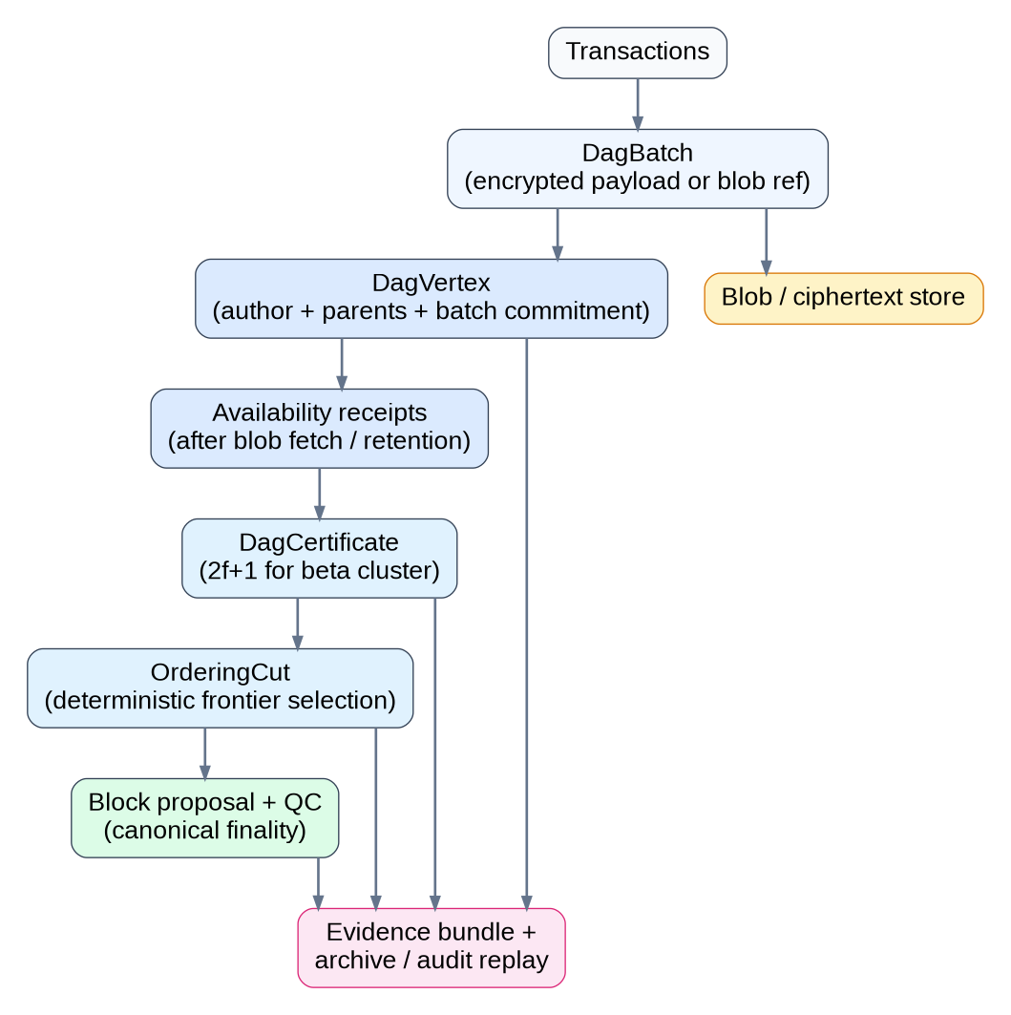
DAG artifact lifecycle and proof boundaries
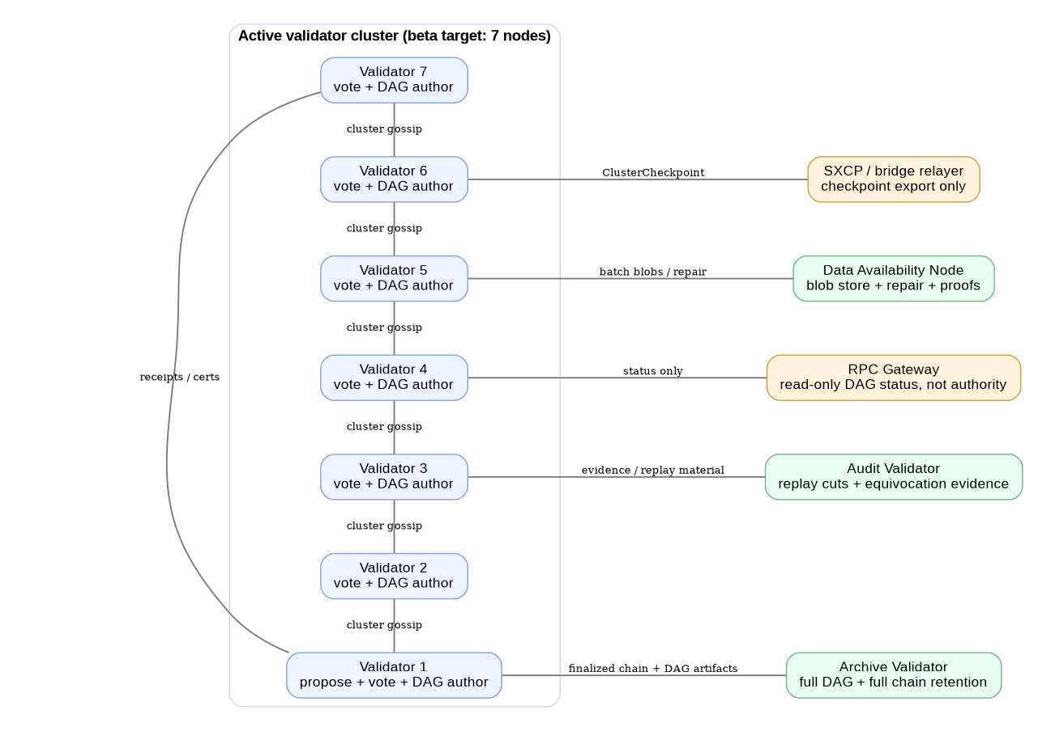
Suggested beta node topology for DAG rollout

Non-negotiable architectural invariants
- QC remains the only settlement artifact. DAG acceptance is not settlement.
- Cluster-local first. Cross-cluster traffic carries checkpoints, not raw vertex floods.
- Availability before ordering. No uncertified or unavailable vertex can influence canonical order.
- Deterministic cut generation. No local heuristics or wall-clock tie-breakers.
- Hard epoch boundaries. Old graph material cannot bleed forward indefinitely.
- Encrypted batches. The DAG must not create a pre-decryption MEV leak.
- Auditability. Every slashable DAG event must leave durable evidence.
Source anchors: PoSy_updated.docx, 03-proof-of-synergy-consensus.md, Synergy_Network_Roadmap (1).docx, Synergy_Network_Security_Implementation_Specification.docx, src/role_profiles.rs, src/p2p/networking.rs.

Dependency-ordered integration roadmap
This section deliberately avoids forcing the work into an arbitrary phase count. The right implementation order is dictated by dependencies and security boundaries, not by presentation aesthetics.

1. Canonicalize current mismatches before writing DAG code
The current code and docs disagree on several parameters that directly affect DAG safety.
- Resolve the beta cluster size mismatch: source defaults say 7, validator reorganization uses 5, broader spec text often targets 30.
- Resolve epoch cadence and randomness design before DAG parent selection depends on them.
- Decide whether beta DAG certificates are identity-count thresholded (2f+1) while finality remains synergy-weighted. That is the cleaner first-release design.
- Freeze the exact non-goals for release one: no global DAG, no speculative parallel execution as a first dependency, no new public ports by default.
Recommended output: a short ADR pack plus a canonical config document that overrides stale defaults.

2. Add a dedicated DAG module and stores
Create a new module tree such as src/dag/ or src/consensus/dag/ rather than burying DAG logic piecemeal inside the existing consensus file.
At minimum, add:
- object definitions for batch, vertex, receipt, certificate, cut, checkpoint, evidence;
- a DAG store separate from canonical chain state;
- a batch/blob store for DA and archive roles;
- deterministic validation utilities for parent checks, expiry checks, and cut generation.
Do not overload TX_POOL as the long-term DAG store. The current pool is a flat list and is cleared wholesale after commit. DAG rollout needs explicit per-batch lifecycle management.

3. Extend the P2P message plane and cluster transport
Add new NetworkMessage variants and keep them cluster-scoped wherever possible. The first release should support at least these categories:
- DagVertex
- RequestDagVertex / DagVertices
- FetchDagBatch / DagBatchBlob
- AvailabilityReceipt
- DagCertificate
- OrderingCutSummary
- ClusterCheckpoint
- DagEvidence
Reuse the existing handshake capabilities field to negotiate support, for example:
- dag-cert-v1
- dag-archive-v1
- dag-da-v1
- dag-proof-export-v1
Keep transport discipline tight:
- one-author-one-vertex-per-round in beta;
- per-peer byte budgets;
- strict expiry windows;
- parent-diversity rules;
- no receipt unless the batch is durably retrievable.

4. Insert DAG-certified ordering into the proposer and validator path
This is the most important runtime change.
In consensus_algorithm.rs:
- replace direct block assembly from TX_POOL with block assembly from a certified ordering cut;
- keep leader selection and block timing under PoSy unless and until you deliberately redesign them;
- keep the QC finality path unchanged for the first release.
In block.rs:
- add header commitments for ordering cut and availability roots;
- update block hashing and validation logic carefully;
- version the block format if necessary so migration is explicit.
In validator verification:
- verify certificate validity;
- verify parent consistency and epoch scope;
- verify deterministic cut construction;
- verify transaction root agreement with the cut;
- then verify state transition and proceed to QC voting.

5. Tighten entropy, cluster math, and anti-cartel evidence
The existing source bundle already exposes three places where DAG rollout would be unsafe without fixes.

Replace wall-clock randomness in shared ordering decisions
Epoch randomness used by multiple validators must be derived from canonical shared inputs only. Remove local wall-clock dependence from any randomness that influences parent selection, leader selection, or ordering rules.

Canonicalize cluster size and threshold math
Use a single source of truth for:
- cluster size;
- receipt threshold;
- quorum threshold;
- archive and audit retention depth;
- censorship and parent-diversity expectations.

Upgrade cartel and censorship evidence collection
Current anti-cartel logic is not enough for DAG. Add evidence capture for:
- same-author same-round equivocation;
- private conflicting frontiers;
- repeated omission of eligible certified vertices;
- suspicious parent concentration;
- repeated false availability claims.

6. Extend sync, archive, audit, and DA services
The current sync stack is chain-first. DAG rollout needs bounded artifact sync.
Recommended split:
- live validators keep only the working frontier plus bounded retention;
- archive validators keep full finalized DAG history and batch blobs;
- audit validators keep replay material and slashable evidence;
- data-availability nodes serve blobs, repair missing data, and index proofs.
This is operationally aligned with the existing role system, which already names these roles. The missing piece is implementation.

7. Extend RPC, explorer, and wallet semantics honestly
Do not blur DAG acceptance and settlement in client-facing APIs.
Keep finalized-chain APIs stable where possible, then add read-only DAG diagnostics such as:
- synergy_getDagStatus
- synergy_getClusterDagHead
- synergy_getDagVertex
- synergy_getDagCertificate
- synergy_getDagConflicts
- synergy_getClusterDagHealth
- synergy_getOrderingCut
- synergy_getDagEvidence
Also add a transaction lifecycle that is honest about provisional states, for example:
- received
- batched
- dag-accepted
- availability-certified
- ordered
- QC-finalized
- executed

8. Roll out in an order that contains blast radius
A practical rollout sequence is:
- single-cluster lab run with archive and audit roles;
- two-cluster internal run with checkpoint export only;
- adversarial simulation: equivocation, stale replay, withholding, censorship, spam, partition, bridge loss;
- canary beta cluster with rollback guardrails;
- wider beta enablement only after replay and evidence export are stable.
Do not ship release one with speculative parallel execution if the dissemination DAG is not already stable. Deterministic execution DAG work can come later.
Source anchors: src/consensus/consensus_algorithm.rs, src/consensus/dual_quorum.rs, src/p2p/messages.rs, src/p2p/networking.rs, src/sync/manager.rs, src/block.rs, src/role_profiles.rs, Synergy_Network_Roadmap (1).docx, Synergy_Network_Security_Implementation_Specification.docx.

DAG-specific security enforcement plan
DAG systems fail in different ways than plain linear chains. The right response is not to fear DAGs in the abstract; it is to reject insecure DAG variants and enforce the right controls at the right layers.
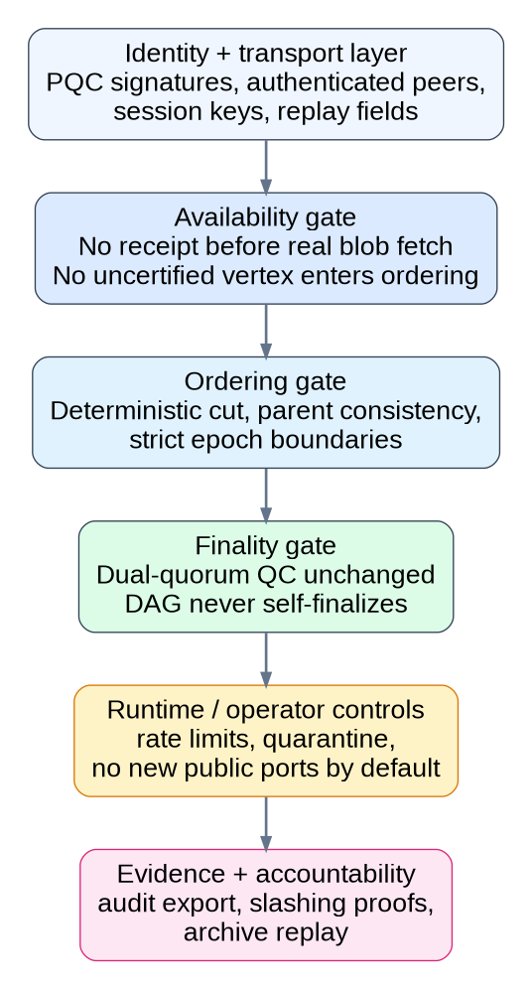
Security enforcement layers for a Synergy cluster DAG

Threat-control matrix
- Spam, replay, and stale vertices. Current P2P code has no DAG-specific expiry or byte-budget discipline. Add strict expiry, per-peer budgets, and capability-gated DAG ingress.
- Data withholding and fake availability. The source bundle has no receipt or blob-proof object yet. Require durable fetch before receipt and ban uncertified ordering.
- Same-author equivocation. There is no DAG author-round rule today. Enforce one-author-one-vertex-per-round and export evidence immediately.
- Hidden sub-DAG or private conflicting frontier. There is no DAG frontier monitor yet. Reject stale private branches, checkpoint visible progress, and slash provable conflicting proofs.
- Censorship and parent omission. Current cartel logic is too thin for DAG evidence. Audit omission of eligible certified vertices and suspicious parent concentration.
- MEV leakage and premature disclosure. The base transaction path is plaintext-oriented. Use encrypted batches and protocol-timed decryption.
- Cluster collusion and score gaming. Current cartel thresholds exceed beta cluster size. Rework thresholds and use DAG-native evidence instead of generic correlation only.
- Partition, eclipse, and bridge loss. P2P and SXCP already have trust boundaries, but no DAG-specific safety mode. Pause authoritative ordering if graph visibility is unsafe.
- Finality confusion in UX. RPC and wallet semantics do not distinguish DAG progress from settlement. Expose DAG progress separately from QC finality.
- State and history blow-up. Sync and retention are chain-shaped. Bound hot retention and keep full DAG history only on archive, audit, and DA roles.

Non-negotiable controls
- No uncertified ordering. If a vertex lacks valid availability proof, it does not exist for ordering purposes.
- No skipped authentication for DAG control traffic. Every vertex, receipt, certificate, checkpoint, and evidence bundle must be strictly signed and verified.
- No new public ports by default. Reuse existing trust surfaces and keep public exposure narrow.
- No weakening of QC verification. DAG optimization must never undercut the finality path.
- No optimistic continuation after graph-integrity failure. Quarantine or degrade rather than guessing.
- No operator ambiguity about settlement. “QC-finalized” must remain the only settled state.

Assurance work that should accompany rollout
- property tests for DAG invariants, deterministic ordering, expiry, and proof validation;
- adversarial simulation for replay, withholding, equivocation, censorship, and partitions;
- archive/audit replay that reconstructs cuts from stored artifacts;
- model checking or formal reasoning around “no uncertified input reaches finality”;
- external review that covers the DAG availability layer, not just legacy PoSy components.
Source anchors: Synergy_Network_Security_Implementation_Specification.docx, 09-threat-model-security-patent-relevant-effects.docx, src/p2p/networking.rs, src/rpc/rpc_server.rs, src/consensus/cartel_detection.rs, src/sxcp/mod.rs.

Concrete file touchpoint plan
This is the practical coding map for the engineering team.

Priority 1: files that gate the first usable DAG release
- src/consensus/consensus_algorithm.rs — insert the DAG manager, certified-frontier selection, and batch-retirement logic.
- src/consensus/dual_quorum.rs — keep QC finality intact, remove local-randomness ambiguity, and prepare for cleaner vote transport later.
- src/block.rs — add ordering-cut and availability commitments plus validation.
- src/p2p/messages.rs — add DAG wire types.
- src/p2p/networking.rs — add cluster gossip, fetch, repair, budgets, and capability flags.
- src/sync/*.rs — add DAG artifact sync for archive, audit, and DA roles.
- src/validator.rs — canonicalize cluster size, cluster assignment, and slashing hooks.
- src/config/mod.rs — add the [dag] namespace and matching environment overrides.

Priority 2: files that make the rollout operable and enforceable
- src/rpc/rpc_server.rs — add DAG diagnostics, evidence export, and honest lifecycle APIs.
- src/consensus/cartel_detection.rs — add DAG-native evidence and workable beta thresholds.
- src/consensus/synergy_score.rs — preserve weighting in finality and rewards, not basic availability.
- src/role_profiles.rs and src/role_runtime.rs — turn DA, archive, and audit profiles into real rollout paths.
- src/token.rs — preserve cluster reward continuity and add DAG slashing categories.

Priority 3: files that round out ergonomics and deployment
- src/bin/* — add DAG-aware startup modes and health expectations for the role-specific binaries.

Remaining blind spots and the most useful next inputs
This merged report is materially better than the earlier one because it now includes direct runtime-source review. It is still not literally omniscient.
The most useful additional inputs would be:
- the full synergy-node-control-panel repository;
- real genesis.json, node.toml, peers.toml, and aegis.toml examples;
- deployment artifacts such as systemd units, Dockerfiles, Nginx templates, and rollout scripts;
- a sample generated operator bundle from the control panel;
- any prior audit, threat-model, incident, or load-test material.
Those items would allow a true end-to-end DAG rollout plan covering runtime, provisioning, UI, deployment, and operations without inference gaps.

Appendix A. Complete src.zip inventory reviewed

Root files
- address.rs
- block.rs
- broadcast.rs
- Cargo.toml
- contracts.rs
- lib.rs
- logging.rs
- main.rs
- role_profiles.rs
- role_runtime.rs
- token.rs
- token_new.rs
- token_old.rs
- transaction.rs
- utils.rs
- validator.rs
- wallet.rs

aivm/
- aivm/chat_interface.rs
- aivm/distributed_ai.rs
- aivm/interoperability.rs
- aivm/mod.rs
- aivm/model_registry.rs
- aivm/provider.rs
- aivm/runtime.rs
- aivm/verifier.rs
- aivm/wasm_vm.rs

bin/
- bin/synergy-aegis-cryptography-node.rs
- bin/synergy-analytics-and-simulation-node.rs
- bin/synergy-archive-validator-node.rs
- bin/synergy-audit-validator-node.rs
- bin/synergy-committee-node.rs
- bin/synergy-cross-chain-verifier-node.rs
- bin/synergy-data-availability-node.rs
- bin/synergy-governance-auditor-node.rs
- bin/synergy-indexer-and-explorer-node.rs
- bin/synergy-observer-light-node.rs
- bin/synergy-oracle-node.rs
- bin/synergy-relayer-node.rs
- bin/synergy-rpc-gateway-node.rs
- bin/synergy-security-council-node.rs
- bin/synergy-synq-execution-node.rs
- bin/synergy-treasury-controller-node.rs
- bin/synergy-uma-coordinator-node.rs
- bin/synergy-validator-node.rs
- bin/synergy-witness-node.rs
- bin/wallet_pqc_cli.rs

config/
- config/mod.rs

consensus/
- consensus/cartel_detection.rs
- consensus/consensus_algorithm.rs
- consensus/dao_governance.rs
- consensus/dual_quorum.rs
- consensus/mod.rs
- consensus/synergy_score.rs
- consensus/tests.rs
- consensus/vrf.rs

crypto/
- crypto/mod.rs
- crypto/pqc.rs

gas/
- gas/mod.rs

node/
- node/mod.rs
- node/synergyd.rs

p2p/
- p2p/identity.rs
- p2p/messages.rs
- p2p/mod.rs
- p2p/networking.rs

rpc/
- rpc/mod.rs
- rpc/rpc_server.rs
- rpc/rpc_server.rs.bak

sxcp/
- sxcp/mod.rs

sync/
- sync/fast_sync.rs
- sync/full_sync.rs
- sync/manager.rs
- sync/mod.rs
- sync/state_sync.rs
- sync/validation.rs

synergy-address-engine/
- synergy-address-engine/Cargo.lock
- synergy-address-engine/Cargo.toml
- synergy-address-engine/devnet_generator.rs
- synergy-address-engine/readme_doc.md
- synergy-address-engine/src/main.rs

synq/
- synq/compiler.rs
- synq/interpreter.rs
- synq/mod.rs

Appendix B. Document corpus reviewed
- 00-a-toc.docx
- 00-a-toc.md
- 00-b-front-matter.docx
- 00-b-front-matter.md
- 01-context-motivation-design.docx
- 01-context-motivation-design.md
- 02-system-architecture.docx
- 02-system-architecture.md
- 03-proof-of-synergy-consensus.docx
- 03-proof-of-synergy-consensus.md
- 04-aegis-pqc-core.docx
- 04-aegis-pqc-core.md
- 05-interoperability-and-execution-protocols.docx
- 05-interoperability-and-execution-protocols.md
- 06-smart-contract-language-and-execution.docx
- 06-smart-contract-language-and-execution.md
- 07-synergy-wallet-architecture.docx
- 07-synergy-wallet-architecture.md
- 08-governance-economics-and-operations.docx
- 08-governance-economics-and-operations.md
- 09-threat-model-security-patent-relevant-effects.docx
- 09-threat-model-security-patent-relevant-effects.md
- 10-roadmap-and-strategic-outlook.docx
- 10-roadmap-and-strategic-outlook.md
- 11-appendices.docx
- 11-appendices.md
- Aegis_updated.docx
- Master Network, Ports, and Nginx Configuration Manual.docx
- Master Network, Ports, and Nginx Configuration Manual.pdf
- network_configs.md
- PoSy_updated.docx
- pqc-name-formatting.docx
- research.pdf
- rpc-methods.md
- SNRG_Denomination_Precision_Spec.md
- SXCP_PPA_Specification_Aligned_FULL_v2_updated.docx
- Synergy Network Address Formatting Standard.pdf
- synergy-network-full-whitepaper.pdf
- Synergy_Network_Network_Configuration_Specification.docx
- Synergy_Network_Node_Technical_Specification.docx
- Synergy_Protocol_Naming_Encoding_Standards.docx
- Synergy_Protocol_Naming_Encoding_Standards.pdf
- Synergy_Wallet_Specification_v3.pdf
- whitepaper-alignment-gap-report.md

Appendix C. Proposed additive [dag] config namespace
[dag]
enabled = false
mode = "certified_mempool"
cluster_scope_only = true
require_encrypted_batches = true
availability_threshold = "2f_plus_1"
allow_uncertified_ordering = false
max_vertices_per_round_per_validator = 1
min_parent_diversity = 3
vertex_expiry_rounds = 4
batch_max_bytes = 262144
batch_max_age_ms = 1500
max_frontier_vertices = 1024
gc_finality_depth = 256
emit_dag_evidence = true
quarantine_on_integrity_failure = true
advertise_capabilities = ["dag-cert-v1", "dag-archive-v1"]

Appendix D. Proposed DAG RPC additions
- synergy_getDagStatus
- synergy_getClusterDagHead
- synergy_getDagVertex
- synergy_getDagCertificate
- synergy_getDagConflicts
- synergy_getClusterDagHealth
- synergy_getOrderingCut
- synergy_getDagEvidence
- synergy_getDagRetentionStatus
- synergy_getValidatorDagActivity

Appendix E. Mermaid-source snippets for reuse in docs and ADRs

E1. Current path versus target hybrid path
flowchart LR
subgraph Current[Current testnet-beta PoSy path]
A[TX_POOL] --> B[Leader selection]
B --> C[Block proposal from flat pool]
C --> D[Dual-quorum QC]
D --> E[Linear finalized chain]
end
subgraph Target[Target hybrid validator-cluster DAG]
T1[Tx ingress] --> T2[Encrypted batch]
T2 --> T3[DagVertex]
T3 --> T4[Availability receipts]
T4 --> T5[DagCertificate]
T5 --> T6[OrderingCut]
T6 --> T7[Block proposal]
T7 --> T8[PoSy QC]
T8 --> T9[ClusterCheckpoint]
end

E2. Code touchpoint map
flowchart TB
D[ClusterDagEngine]
D --> C1[consensus_algorithm.rs]
D --> C2[dual_quorum.rs]
D --> N1[p2p messages + networking]
D --> N2[sync + rpc]
D --> S1[block + transaction]
D --> S2[validator + token]
D --> O1[config]
D --> O2[role profiles + runtime]

E3. DAG artifact lifecycle
flowchart LR
A[Transactions] --> B[DagBatch]
B --> C[Batch commitment]
C --> D[DagVertex]
D --> E[AvailabilityReceipt x N]
E --> F[DagCertificate]
F --> G[OrderingCut]
G --> H[Block header commitments]
H --> I[PoSy QC]
I --> J[ClusterCheckpoint]
F --> K[Evidence bundle]
G --> K
I --> K

E4. Beta DAG topology
flowchart LR
subgraph Cluster[Active validator cluster]
V1[Validator 1]
V2[Validator 2]
V3[Validator 3]
V4[Validator 4]
V5[Validator 5]
V6[Validator 6]
V7[Validator 7]
end
Cluster --> A[Archive Validator]
Cluster --> U[Audit Validator]
Cluster --> D[Data Availability Node]
Cluster --> R[RPC Gateway]
Cluster --> X[SXCP bridge relayer]

E5. Security enforcement layers
flowchart LR
T1[Spam / replay] --> I[Ingress controls]
T2[Data withholding] --> A[Availability controls]
T3[Equivocation] --> A
T4[Censorship / MEV] --> O[Ordering controls]
I --> A --> O --> F[Finality controls] --> P[Ops controls]
T3 --> P

Appendix F. Primary source anchors used repeatedly in this merged report
- src/consensus/consensus_algorithm.rs
- src/consensus/dual_quorum.rs
- src/consensus/cartel_detection.rs
- src/consensus/synergy_score.rs
- src/validator.rs
- src/block.rs
- src/transaction.rs
- src/p2p/messages.rs
- src/p2p/networking.rs
- src/sync/manager.rs
- src/rpc/rpc_server.rs
- src/role_profiles.rs
- src/role_runtime.rs
- src/token.rs
- PoSy_updated.docx
- 03-proof-of-synergy-consensus.md
- Synergy_Network_Roadmap (1).docx
- Synergy_Network_Security_Implementation_Specification.docx
- Synergy_Network_Node_Technical_Specification.docx
- Synergy_Network_Network_Configuration_Specification.docx
- Master Network, Ports, and Nginx Configuration Manual.docx
- rpc-methods.md
- 09-threat-model-security-patent-relevant-effects.docx

